**D. Y. Patil College of College of Engineering and Technology, Kolhapur**

**Department of Computer Science & Engineering**

**Class: SY-A Subject: AOOC**

**Experiment no: 15**

**Group No. 12 Mini Project**

**Title of Mini-Project: ATM Surface Stimulator**

**Problem Statement:**

**The project aims to simulate the user interface of an ATM to provide a virtual, contactless experience for performing basic banking operations like PIN entry, balance inquiry, and cash withdrawal. This helps in testing, training, and improving accessibility without using a physical ATM.**

**Introduction:**

**The ATM Surface Stimulator is a specialized testing and simulation device designed to emulate the tactile and interface conditions of an Automated Teller Machine (ATM). Its primary purpose is to evaluate and validate the surface interactions of ATM touchpoints, such as buttons, screens, and biometric scanners, under various environmental and operational conditions. These devices are widely used in the development, testing, and quality assurance stages of ATM hardware production.**

**The stimulator can replicate a variety of physical inputs, including touch pressure, swipe gestures, fingerprint recognition attempts, and even environmental factors like temperature and humidity. This allows engineers and developers to simulate real-world usage scenarios and ensure that the ATM's surface interface remains responsive, durable, and secure over time.**

**Typically integrated with software systems that log and analyze response data, the ATM Surface Stimulator plays a vital role in improving the user interface (UI) and human-machine interaction (HMI) of banking systems. Moreover, it helps in identifying potential vulnerabilities in touch-based authentication and improving the robustness of input recognition, particularly for outdoor or high-traffic ATMs.**

**This tool is essential in the age of increasing digital banking, where reliability, user experience, and physical security of ATM interfaces are of paramount importance.**

**ATM Surface Stimulators are used to:**

* **Test the touch sensitivity and input accuracy under different conditions (e.g., wet hands, gloves, cold weather).**
* **Evaluate long-term mechanical durability of physical buttons or screens.**
* **Simulate biometric input to test fingerprint or palm recognition modules.**
* **Assess response time and interface lag during multi-input scenarios.**
* **Validate the system's resistance to vandalism, tampering, or unusual usage patterns.**

**System Architecture:**

**The architecture of an ATM Surface Stimulator typically involves a combination of mechanical actuators, sensing modules, and a control and data acquisition system. Here’s a breakdown of the main components:**

**1. Input Simulation Module**

**This module emulates physical user interactions. It consists of:**

* **Robotic Arms / Actuators: Controlled by stepper or servo motors to apply controlled pressure on touchscreens or buttons.**
* **Stylus Tip / Touch Emulators: Designed to mimic a human finger with adjustable pressure, angle, and speed.**
* **Biometric Simulators: Artificial fingerprints or palm replicas can be integrated to test biometric readers.**

**2. Environmental Control Unit (Optional)**

**Simulates real-world environmental conditions:**

* **Temperature and Humidity Sensors**
* **Water/Dust Injection Nozzles (for IP-rating tests)**
* **UV/Light Exposure Modules**

**3. Sensors and Feedback Unit**

**These gather real-time data about the interaction:**

* **Force Sensors: Measure the pressure applied.**
* **Position Sensors: Ensure the actuator aligns correctly with target surfaces.**
* **Response Time Sensors: Detect how quickly the ATM system reacts to inputs.**

**4. Control System (Embedded or PC-Based)**

**Acts as the brain of the stimulator:**

* **Microcontroller/PLC or Industrial PC**
* **Interfaces with actuators and sensors.**
* **Executes predefined test sequences (e.g., 1000 button presses at varied angles).**
* **Controls timing, pressure levels, and sensor reading frequency.**

**5. Software Interface**

**Provides a user-friendly platform to configure, monitor, and log test data:**

* **Test Configuration Panel: Allows engineers to set parameters like pressure, duration, interval, etc.**
* **Data Logging Module: Stores all response metrics for analysis.**
* **Visualization Dashboard: Displays real-time test status, graphs, and alerts.**

**6. Communication Interfaces**

**Facilitate data exchange between the stimulator and host computer:**

* **USB, RS-232, Ethernet or Wi-Fi for remote control.**
* **APIs to integrate with ATM diagnostic or development tools.**

**Typical Workflow**

1. **Engineer configures a test case on the software interface.**
2. **Control system sends commands to actuators.**
3. **Actuators simulate human interaction with ATM surface.**
4. **Sensors collect data on how the ATM responds.**
5. **Software logs and analyzes the data for compliance and performance benchmarks.**

**Module description or working of system:**

**The model of the ATM Surface Stimulator is a modular system built to emulate user interactions with ATM input surfaces in a controlled and programmable environment. The design is centered around a combination of mechanical precision, sensory feedback, and software control to ensure accurate simulation and real-time analysis of ATM responses. This section describes the key subsystems and components that make up the model.**

**1. Mechanical Interaction Unit**

**This is the physical interface that performs the simulated user interactions. It consists of:**

* **Robotic Arm or Linear Actuator Module  
  A programmable electromechanical unit equipped with precision movement control, typically driven by stepper or servo motors. It enables X-Y-Z positioning to target specific regions on the ATM surface.**
* **End-Effector Tool (Touch Emulator)  
  Attached to the robotic arm, this mimics a human finger or stylus. It is capable of varying pressure, angle, and speed to simulate real-life touches, swipes, and button presses.**
* **Biometric Simulation Fixture (Optional)  
  A dedicated fixture with replaceable synthetic fingerprints or palm patterns for testing biometric scanners. Some advanced models may include heat elements to mimic human body temperature.**

**2. Sensor Feedback Module**

**This module ensures precision in interaction and records the feedback from the ATM device.**

* **Force Sensors  
  Placed at the end-effector or underneath the actuator mount to measure the pressure applied during interaction.**
* **Proximity and Position Sensors  
  Ensure accurate alignment of the actuator with the intended contact point on the ATM.**
* **Response Detection Sensors  
  Light, vibration, or signal-based sensors to determine the response time and accuracy of the ATM surface (e.g., button press confirmation, touchscreen input registration).**

**3. Control Unit**

**The central processor that coordinates mechanical movement and sensory feedback.**

* **Microcontroller / PLC / Industrial PC  
  Acts as the command center. It interprets commands from the software interface and translates them into precise actuator movements.**
* **Motor Drivers and Interface Boards  
  Used to control motors, read sensors, and manage communication between mechanical and electrical components.**
* **Power Management System  
  Supplies regulated power to actuators, sensors, and control boards.**

**4. Software and User Interface**

**A graphical software tool installed on a host PC or industrial panel that interacts with the control unit.**

* **Test Configuration Interface  
  Allows users to define test parameters: touch position, pressure, cycle count, time delay, interaction pattern, etc.**
* **Real-Time Monitoring Dashboard  
  Visualizes live data from sensors and actuators. Provides logs of test cycles, errors, and performance statistics.**
* **Data Logging and Reporting Tool  
  Automatically records test results into structured formats (CSV, JSON, or database) for analysis and audit purposes.**
* **Remote Access and API Integration (Optional)  
  Advanced models may include support for remote monitoring or integration into larger ATM testing ecosystems via APIs.**

**5. Frame and Enclosure**

**The physical body that supports and secures all components.**

* **Aluminum/Steel Frame  
  Provides a rigid and vibration-free base for mounting actuators and sensors.**
* **Adjustable Mounting Platform  
  Holds the ATM surface or ATM module in place during testing.**
* **Protective Enclosure  
  Safety shield to protect the user from moving parts and contain debris or dust.**

**Screenshots:**

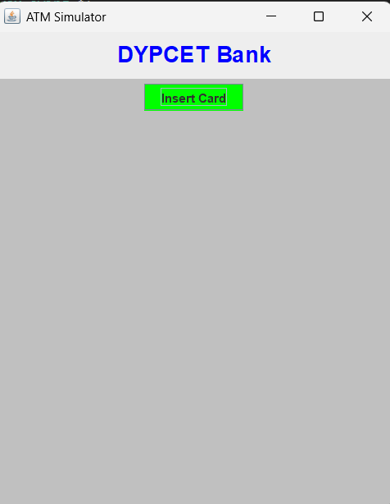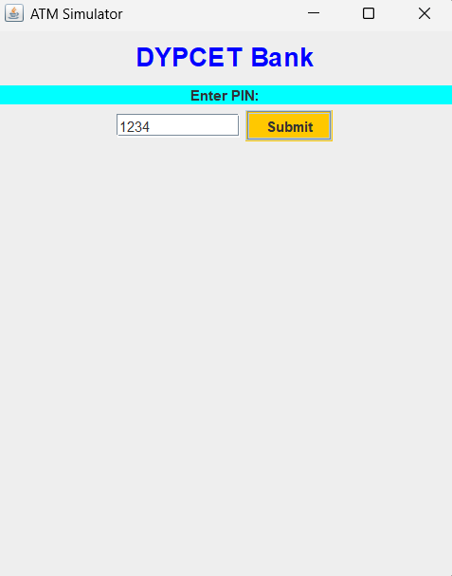

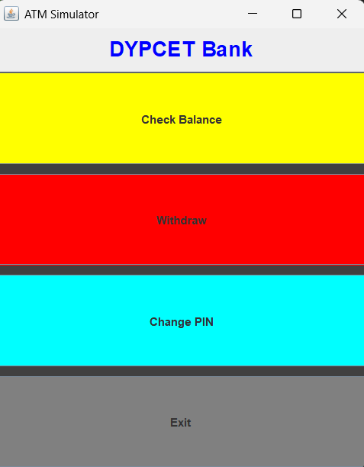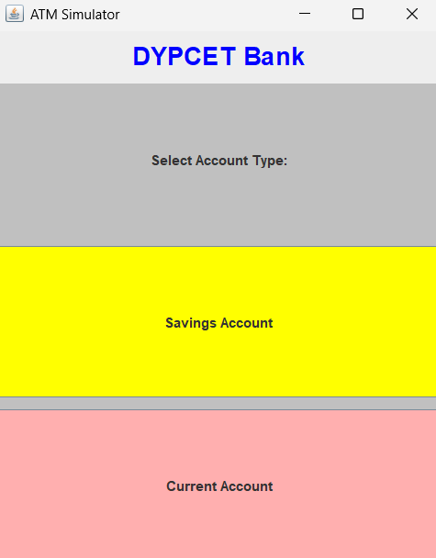

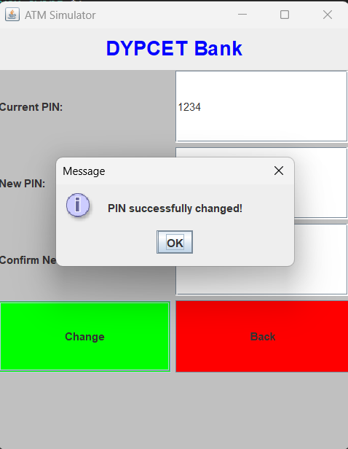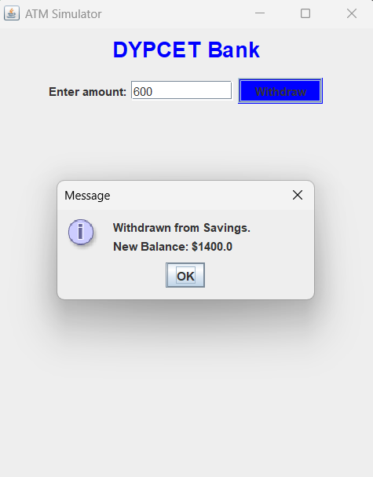

**Group Members:**

|  |  |  |  |
| --- | --- | --- | --- |
| **Unique id** | **Roll No** | **Name of Student** | **Sign** |
| **EN23182404** | **27** | **Varada Pawar** |  |
| **EN23180293** | **33** | **Sayali Dabade** |  |
| **EN23250682** | **41** | **Virendra Katale** |  |
| **EN23179895** | **42** | **Prajval Bhatale** |  |